**System Assembly**

Tools needed:

* Phillips Screw Driver
* Slot/Flathead Screw Driver
* 0.15” Hex/Allen Key[1]
* 0.14” Hex/Allen Key
* 0.12” Hex/Allen Key
* 0.09” Hex/Allen Key
* Torx 27 Ratchet
* #11 Wrench

1) **Place traverse System on rails.**

-If the X-Axis driveshaft is in the tunnel, remove it by pulling it out of the flange bushing opposite the motor. The coupling and pulleys shouldn’t be set, so simply slide them to free the shaft (if they are set, see step 3.)

-At the downwind end of the tunnel, take the traverse system and position it such that the feet with the sliders are in line with rails.

-Slowly slide the feet of the traverse system onto the rails. Make sure force is applied to both sides evenly to prevent binding.

-Once the system is on the rails, slide it a manageable distance down the rails so that it is out of the way.

-Make sure the sensor arm points upwind.

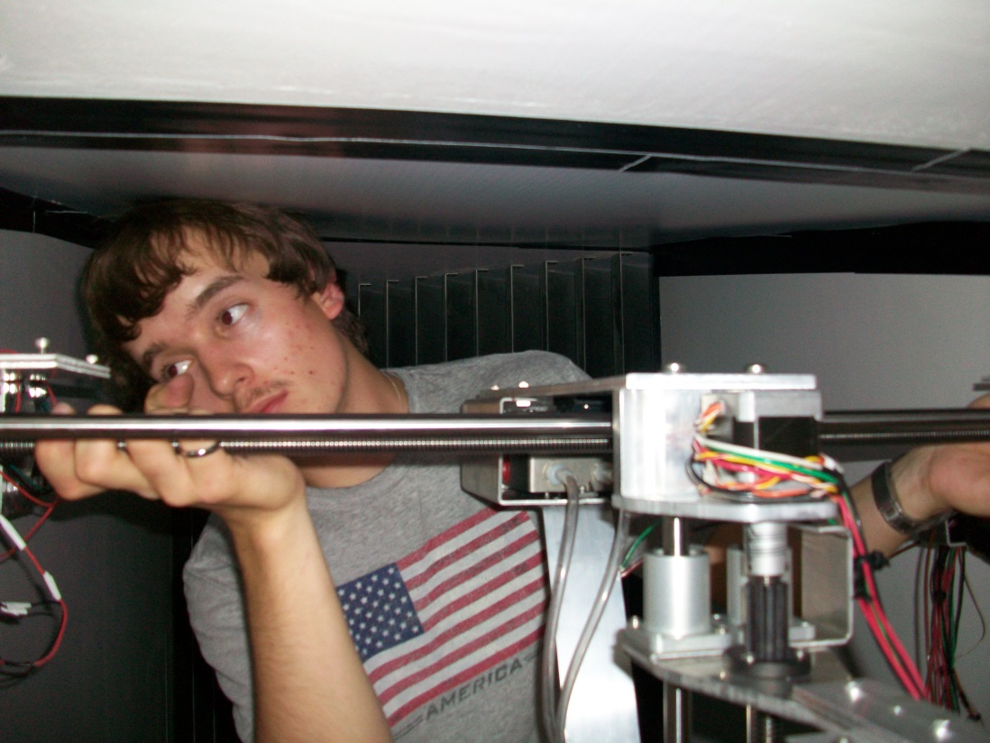

*Sliding the feet of the system onto the rails*

2) **Install X-Axis Drive Shaft**

-With the coupling and pulleys unset, but present on the driveshaft. Insert the drive shaft into the flange bushing opposite the X-Axis Motor.

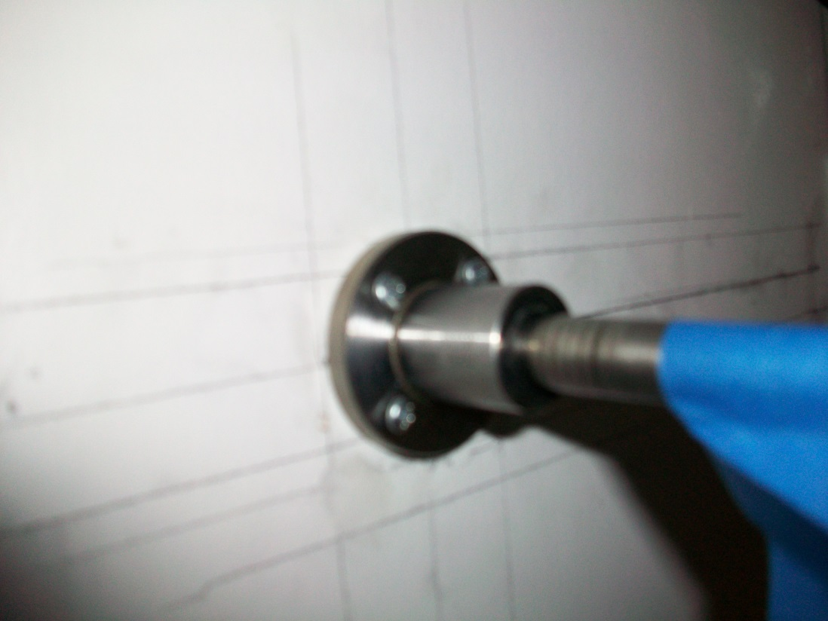

*Insert the drive shaft into this bushing*

3) **Set Driveshaft Motor Coupling and pulleys**

-With the driveshaft set in the bushing, slide the coupling on the driveshaft over the motor shaft as far as it can go.

-Using the 0.09” Hex/Allen Key, tighten the four set screws on the coupling.

-Slide the pulley closest to the X-Motor so that it’s flush with the set coupling.

-Set this pulley using the 0.12” Hex/Allen Key.

-Slide the opposite pulley such that it is the same distance from the wall as the set motor-side pulley.

-Set this pulley also using the 0.12” Hex/Allen Key

-Make sure every component is set tight enough to transfer rotational motion from the motor to the pulleys.

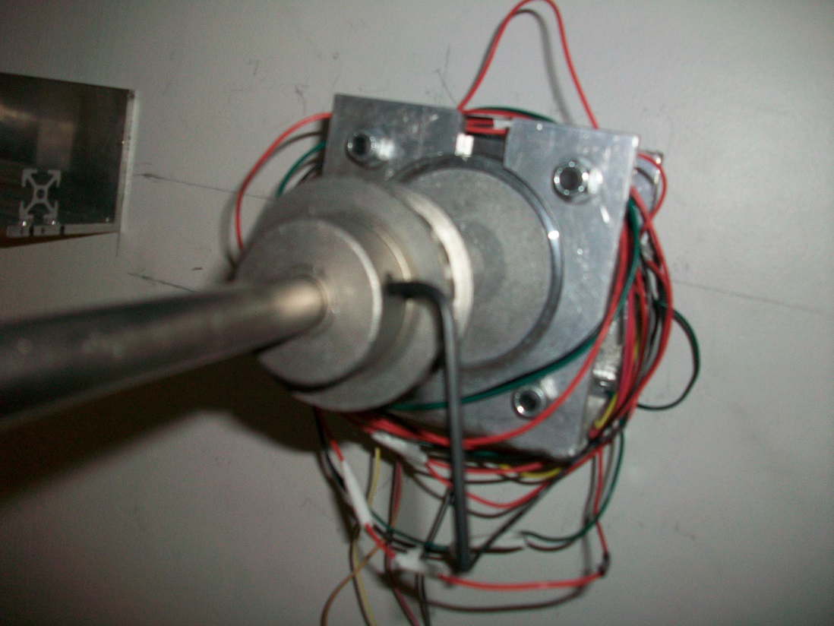

*Setting the Motor-side pulley flush with the coupling*

4) **Attach X-Axis Microswitch Mounting Bracket.**

-On the motor-side L-Bracket which holds the rail, attach the microswitch bracket.

-This bracket utilizes two Torx 27 screws with #11 Hex Bolts.

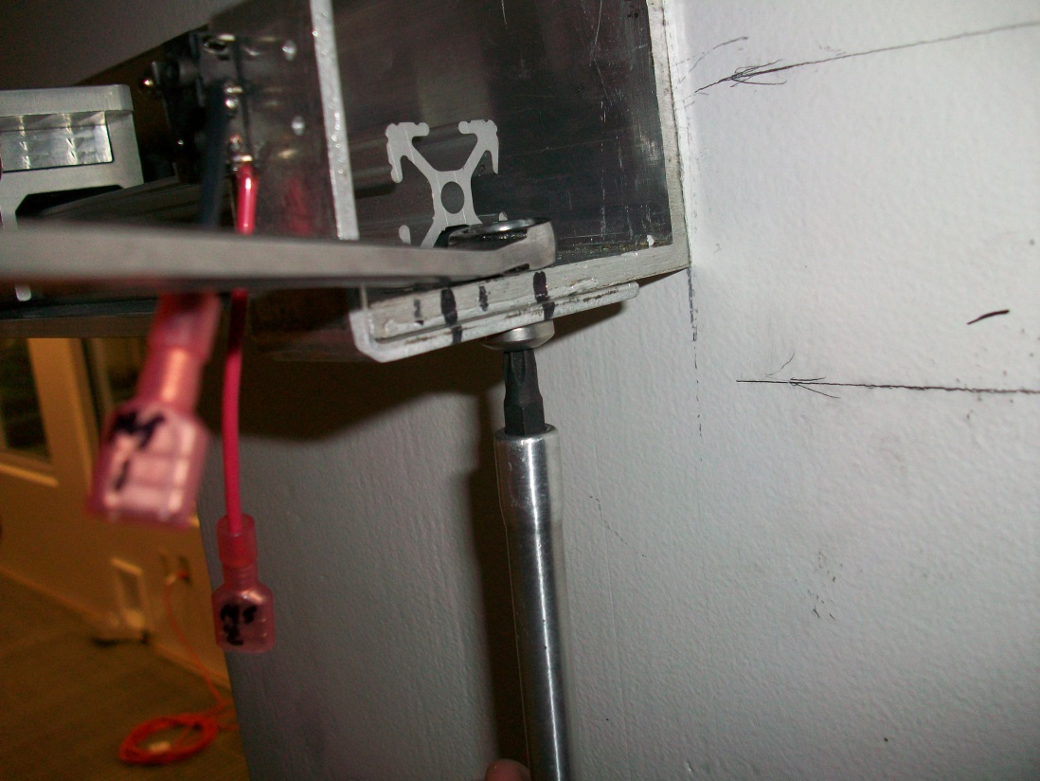

*Using a T27 ratchet and #11 wrench to attach the bracket*

5) **Place Cable Carrier in Trough System**

-Bring the cable carrier into the wind tunnel.

-Unroll the carrier into the elevated trough system on the side opposite the motor.

-Ensure that the side of the carrier with the plugs for the control box is downwind.

-Pull the other end of the cable carrier over so that it ends near the traverse system.

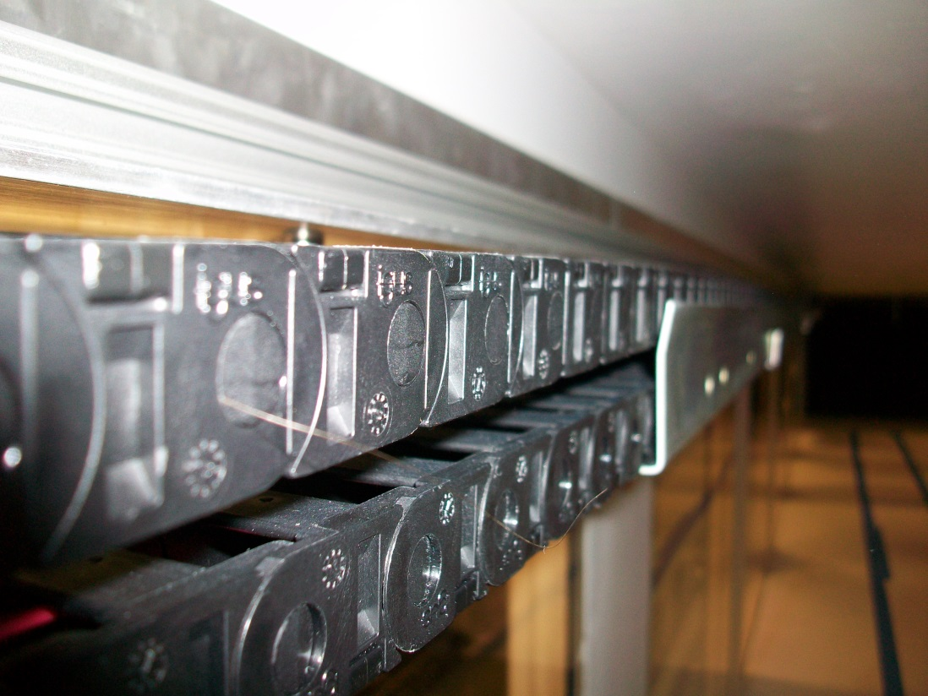

*Doubled over Cable carrier laid into the trough.*

6) **Connect X-Axis Microswitch Wires**

-Find the wire disconnects labeled MS1 and MS2. They extend from the tan 9-pin plug that plugs into the control box.

-Attach the disconnects to the corresponding cables from the X-Axis Microswtich.

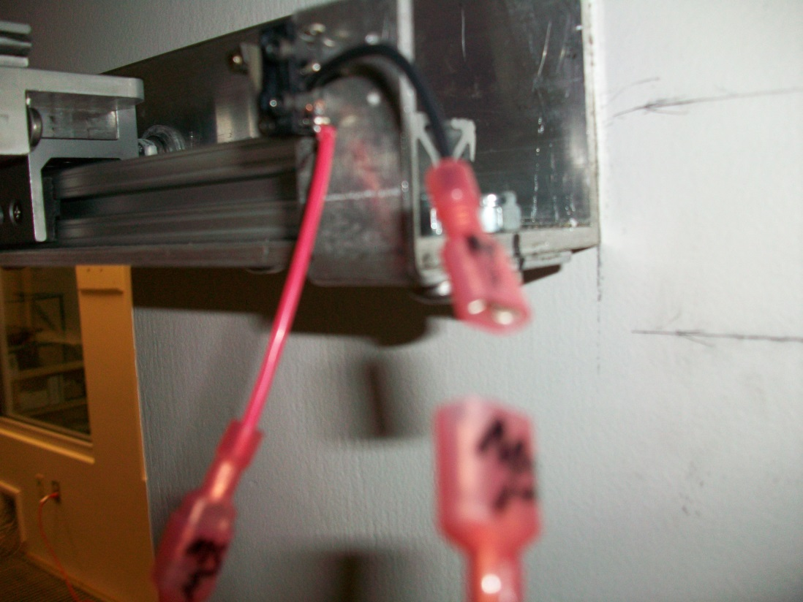

*Both ends of the disconnects should be labeled*

7) **Attach Cable Carrier to Wall Bracket**

-Using 0.15” Hex/Allen Key, attach the cable carrier to the mounted wall bracket opposite the X-Axis motor.

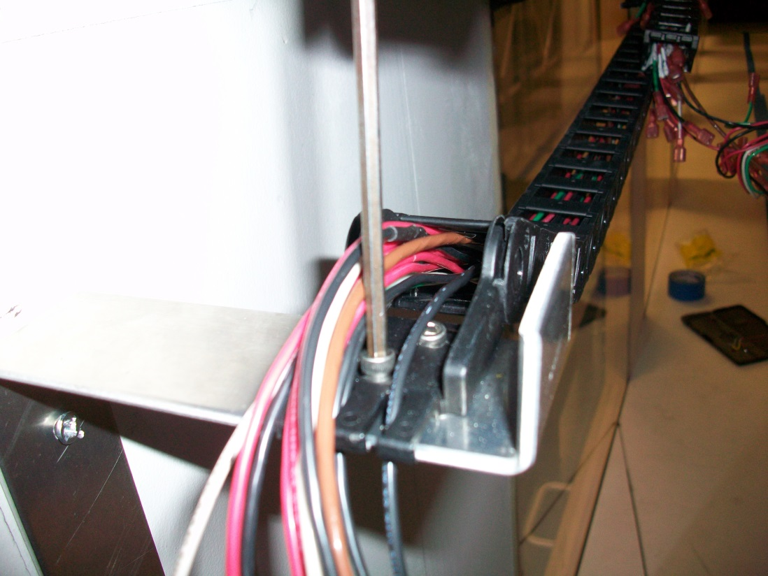

*The cable carrier connection utilizes 2 0.15” Hex socket screws*

8) **Attach Cable Carrier to Traverse System**

-Using 0.15” Hex/Allen key, attach the cable carrier to the traverse system via the extended plate above the Y-Axis Motor.

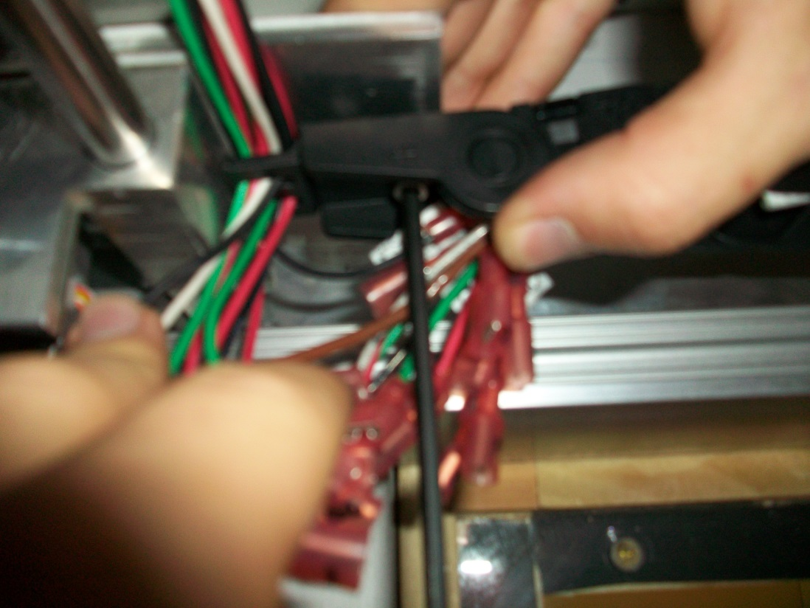

*The cable carrier connection utilizes 2 0.15” Hex socket screws here too*

9) **Connect Cable Disconnects**

-The motors and microswitches utilize 14 different wires.

-Connect these 14 from the cable carrier to the system using the disconnects labeled 1-14.

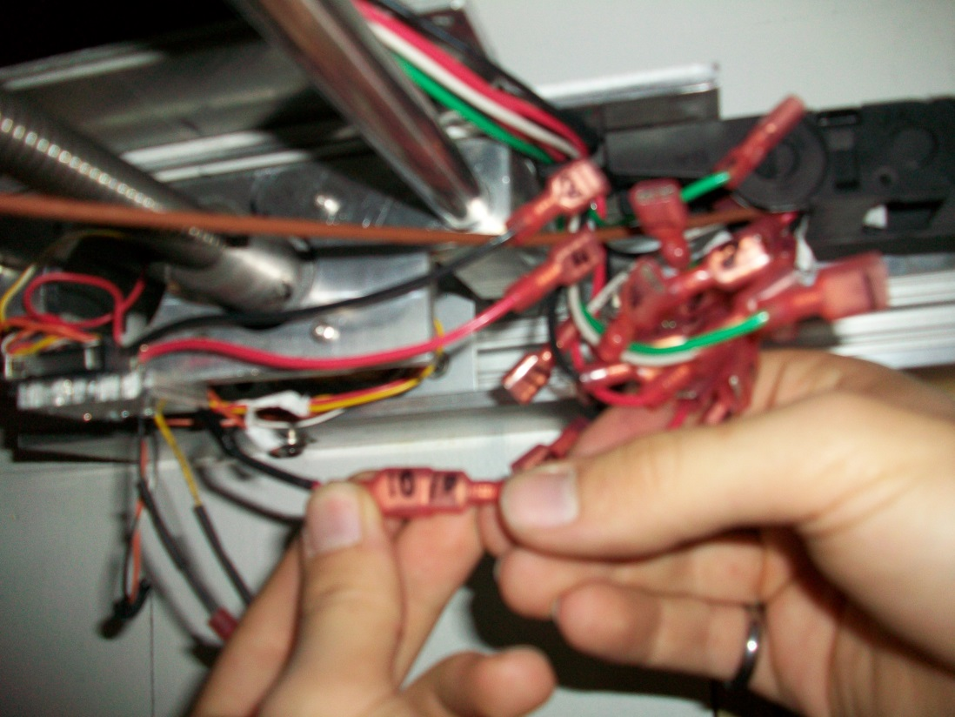

*Each cable disconnect and its pair is numbered*

10) **Connect Instrument Wires**

-The pressure transducer for the Pitot-static tube utilizes a separate shielded wire without a cable disconnect for the signal.

-Using the Slot/Flathead or Philips Screwdriver attach this wire to the appropriate terminals.

-Yellow (Ground) should be the left terminal, red (signal+) should be the right terminal, and the cable shielding should be grounded to the chassis.

-Proceed to attach other instrument wires as necessary.

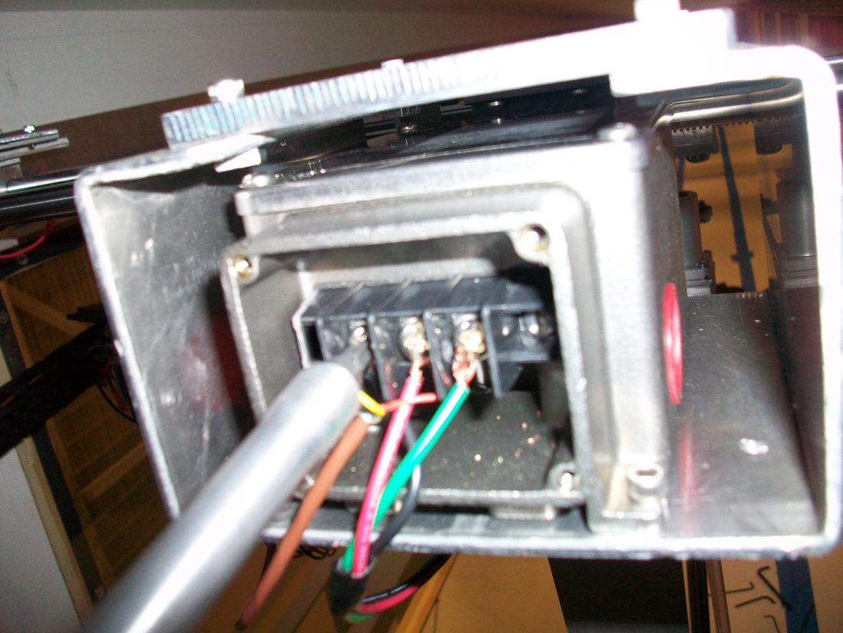

*Attaching the signal cable. The power cables should already be attached.*

11) **Wire Data Aquisition**

-Wire up the DAQ with the CAT5 cables and the sensor signal cables. Please see the wiring diagram in section 2.

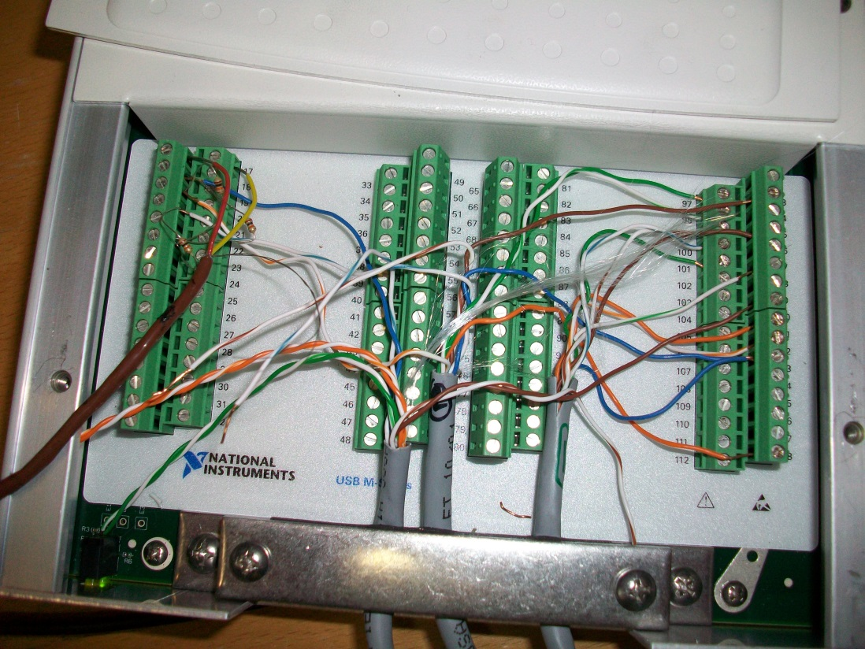

*Wiring diagram presented in section 2.*

12) **Plug Connections into the Control Box**

-Microswitches utilize the 9-pin tan plug on the left side of the box.

-Each motor power plug utilizes 4 pins and plugs into the top row. From left to right the plugs should be X, Y, and Z.

-Cat5 Control cables from the DAQ utilize a 25 pin plug on the bottom right.

-The power supply utilizes a 2 pin plug in the bottom center.

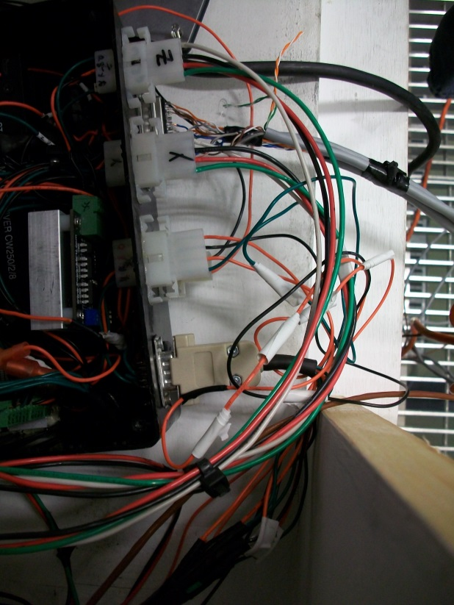

*There should be 6 plugs of various sizes in total.*

13) **Attach Belts**

-Thread the timing belts around each pulley such that both ends of the belts end at the top of the traverse system.

-Unscrew the traverse system clamps using a 0.14” Hex/Allen key.

-Insert both ends of the belt into the clamps, and clamp down on them tightly.

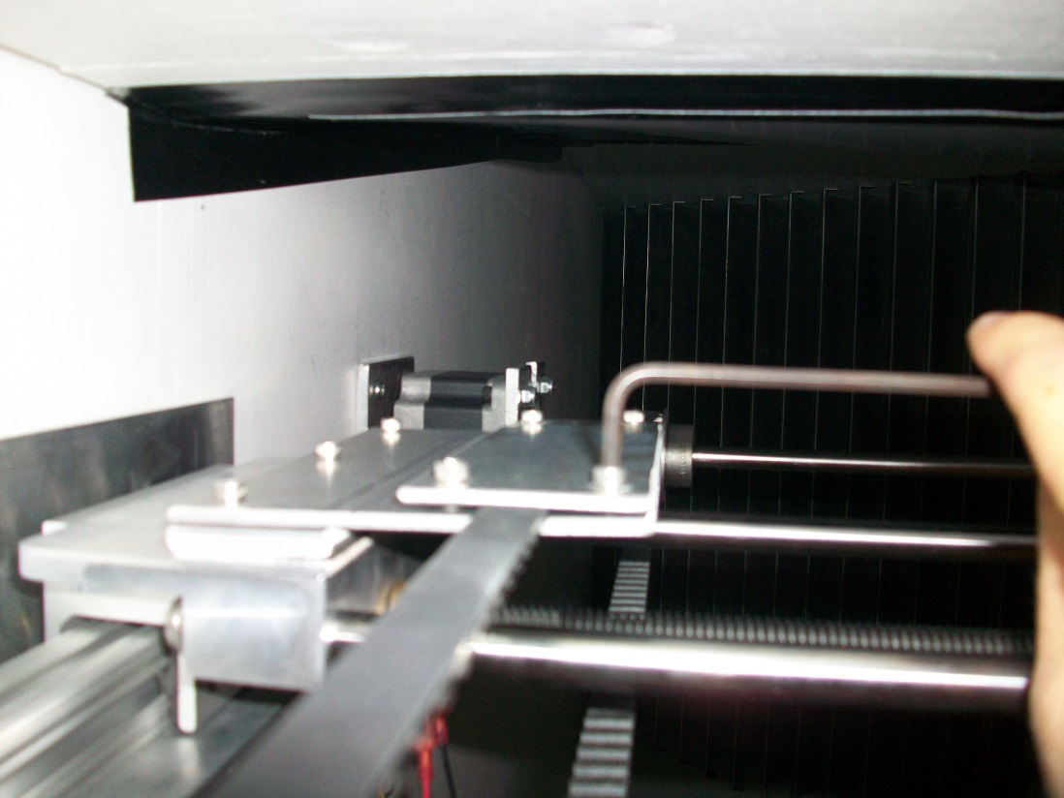

*Insert the free ends into the clamps are far as possible to increase tension.*

14) **Attach Instruments**

-Using a Philips screwdriver loosen one of the screws on the sensor arm extension to allow the arm to swing outward.

-Carefully insert the Pitot tube into the hole at the bottom of the arm.

-Straighten the arm extension and screw it back in.

-Attach the pressure transducer tubes to the Pitot tube.

-Attach other instruments as necessary.

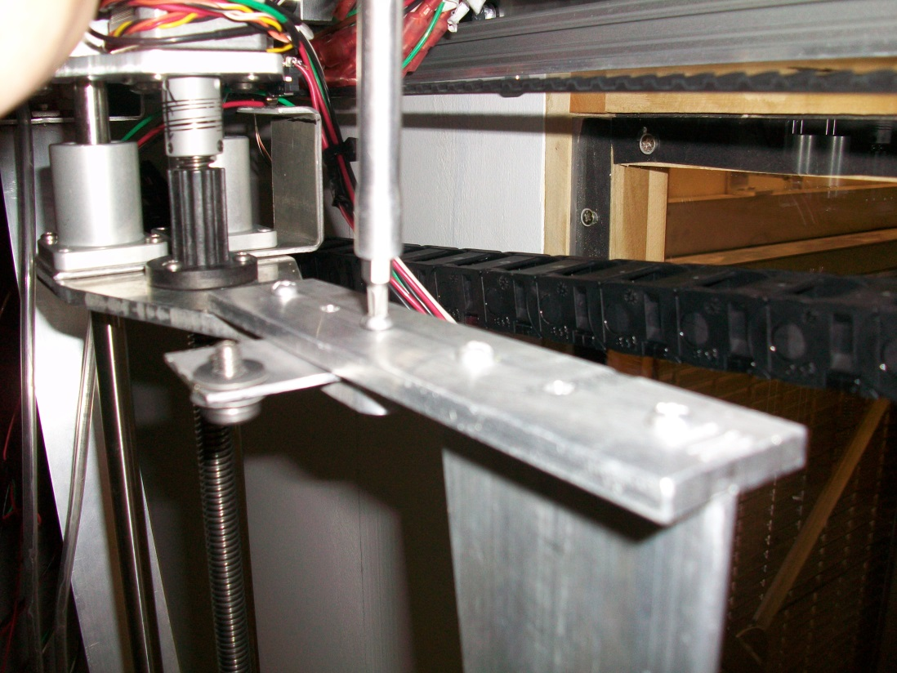

*Unscrew this extension so that the Pitot tube can be inserted more easily.*

**System Assembled.**

You can now turn on the power and use the Labview control program.

1. Hex/Allen Keys measured “Flat-Fla.” All the hex/allen keys needed should be separated in the yellow McMaster-Car bag in the large Craftsmen ratchet set.